
INSTALLATION MANUAL

Table of Contents

Applicable Version…………….……………………………….……………………….………1

Installation....………………….……….………………………………………………………….1

Configuring Worldline……………………………………………………………………………3

Applicable versions

Applications | Versions
PHP | 7.x to 7.4.x
Magento | 2.0.x to 2.4.x

Installation & Upgrade

Please follow the given steps to install and run the Worldline Payment Gateway module

1. Unzip extension package and upload them into Magento root directory.
You will get the “Worldline” folder under the app/code folder. In case, of upgrade replace the folder

2.Enable the module with the following commands
php bin/magento module:enable Worldline_Worldline
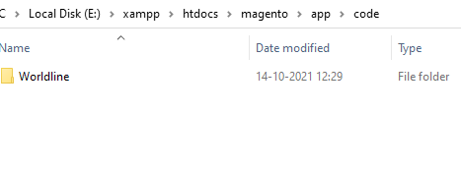
3. Enter the following at the command line to enable the module.
php bin/magento setup:upgrade
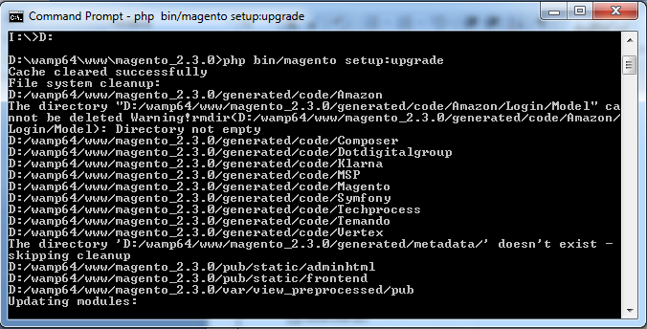
4. Enter below to generate the classes required for the extension to work
php bin/magento setup:di:compile
5. Enter below command for static-content deploy to reflect changes on site.
php bin/magento setup:static-content:deploy
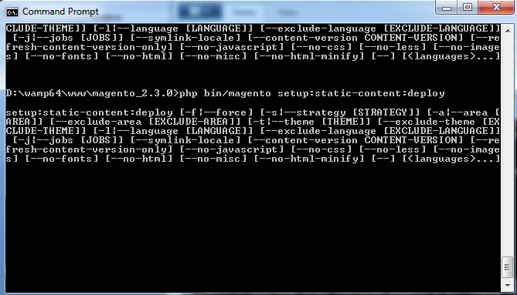

Configuring Worldline

- Go-to admin panel.
- Go-to menu Stores -> Configuration.
- Select “Payment methods” under the “Sales” tab on the left panel.
- Click on Worldline Payment Gateway.
- Configure it as below:
Column Name | Description
Enabled | “Yes” to enable and use, else “No” to disable Worldline
Title | Title Text to display during checkout process
Salt | Enter Salt.
Merchant Code | Enter merchant code.

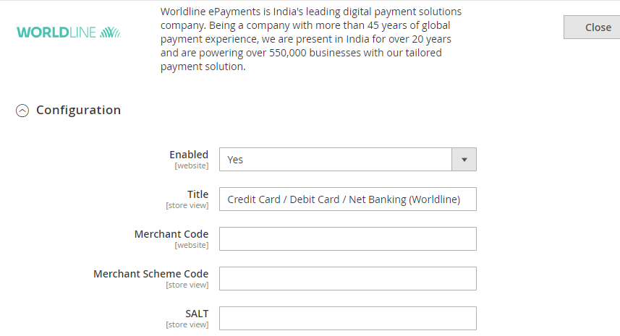
- Now click on “Save Config” on top- right corner.
- Worldline Payment Gateway is now configured & ready to use.

Advanced Configuration

There are also some advanced configuration options you may consider as shown below:

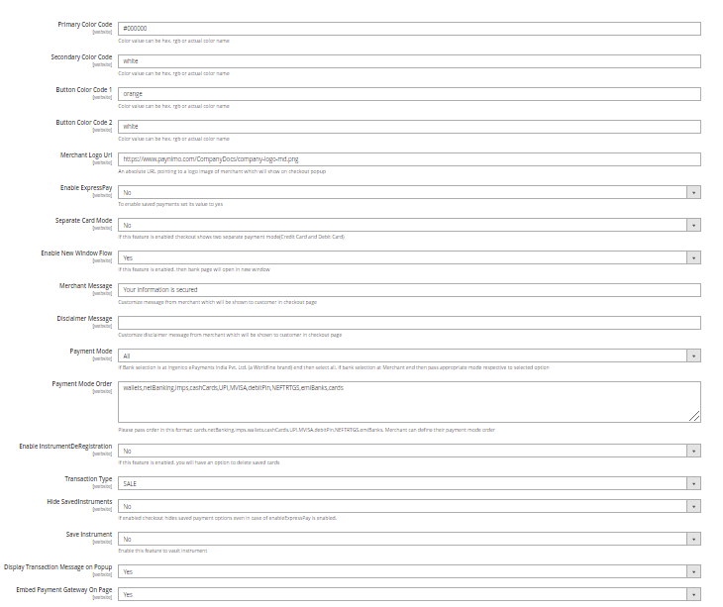

Features List

Dual verification of response:
We are validating responses with a hash value and call again Payment Gateway for dual verification from the payment gateway before updating to the order status.

Reconciliation

Merchants can update the pending status of the order automatically if the payments are successful. This page can be found under Sales > Worldline > Reconciliation

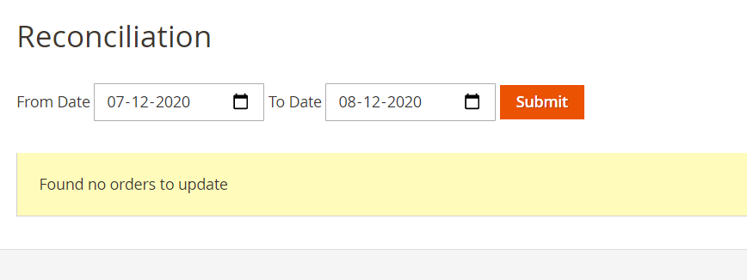

Logs request and response

Daily new file creates for the logs request and response from the server for future reference.

S2S Verification
If we do not receive any response from the payment gateway then after 30 mins, we will get a response from the server and based on the response it will update order status.
To configure S2S URL, contact prod team.

S2S url format : http://DOMAIN_NAME/index.php/worldline/payment/s2sverification or https://DOMAIN_NAME/index.php/Worldline/payment/s2sverification
S2S url example : http://example.com/index.php/worldline/payment/s2sverification

MCG
It supports the multi currency like USD, GBP, SGD and a lot more.

Payment Verification

Merchants can verify the status of their payment by using the Payment Verification page. The payment verification page can be found under sales > Worldline > Payment Verification

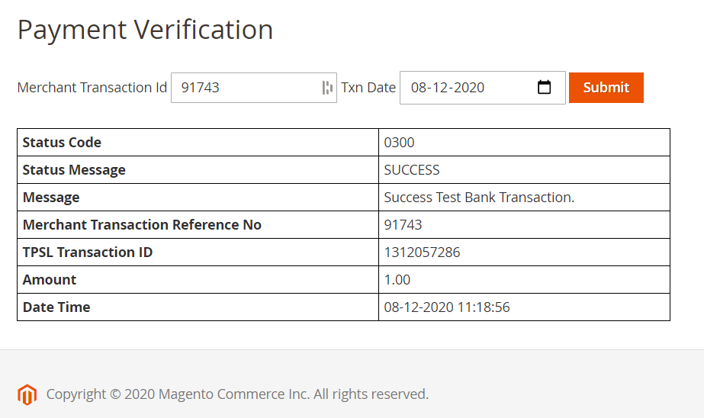

Refund

Merchants should be able to process the refund online for the order whose payment has been done via Worldline.

To refund a order, create a new Credit Memo and click on the Refund button as shown below
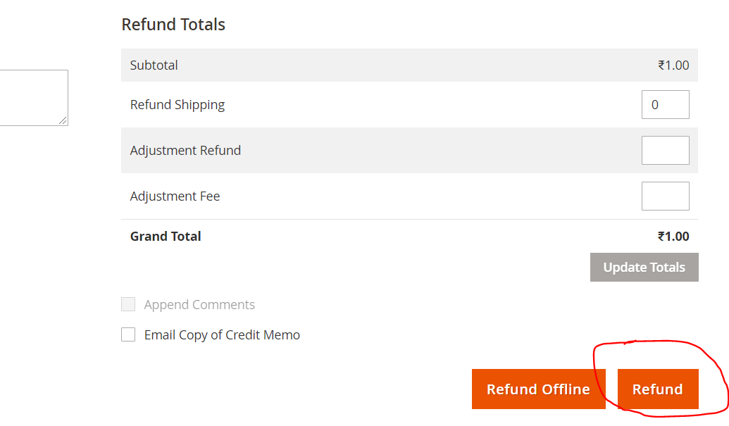

Embed Payment Gateway

After enabling this setting, payment gateway displays like embedded on the page instead of pop-up so user experience would be good.

Documentation link
https://www.tecprocesssolution.com/proto/p2m/client/salt-based-documentation.htm#online

